CAPCOG :: Austin, Texas
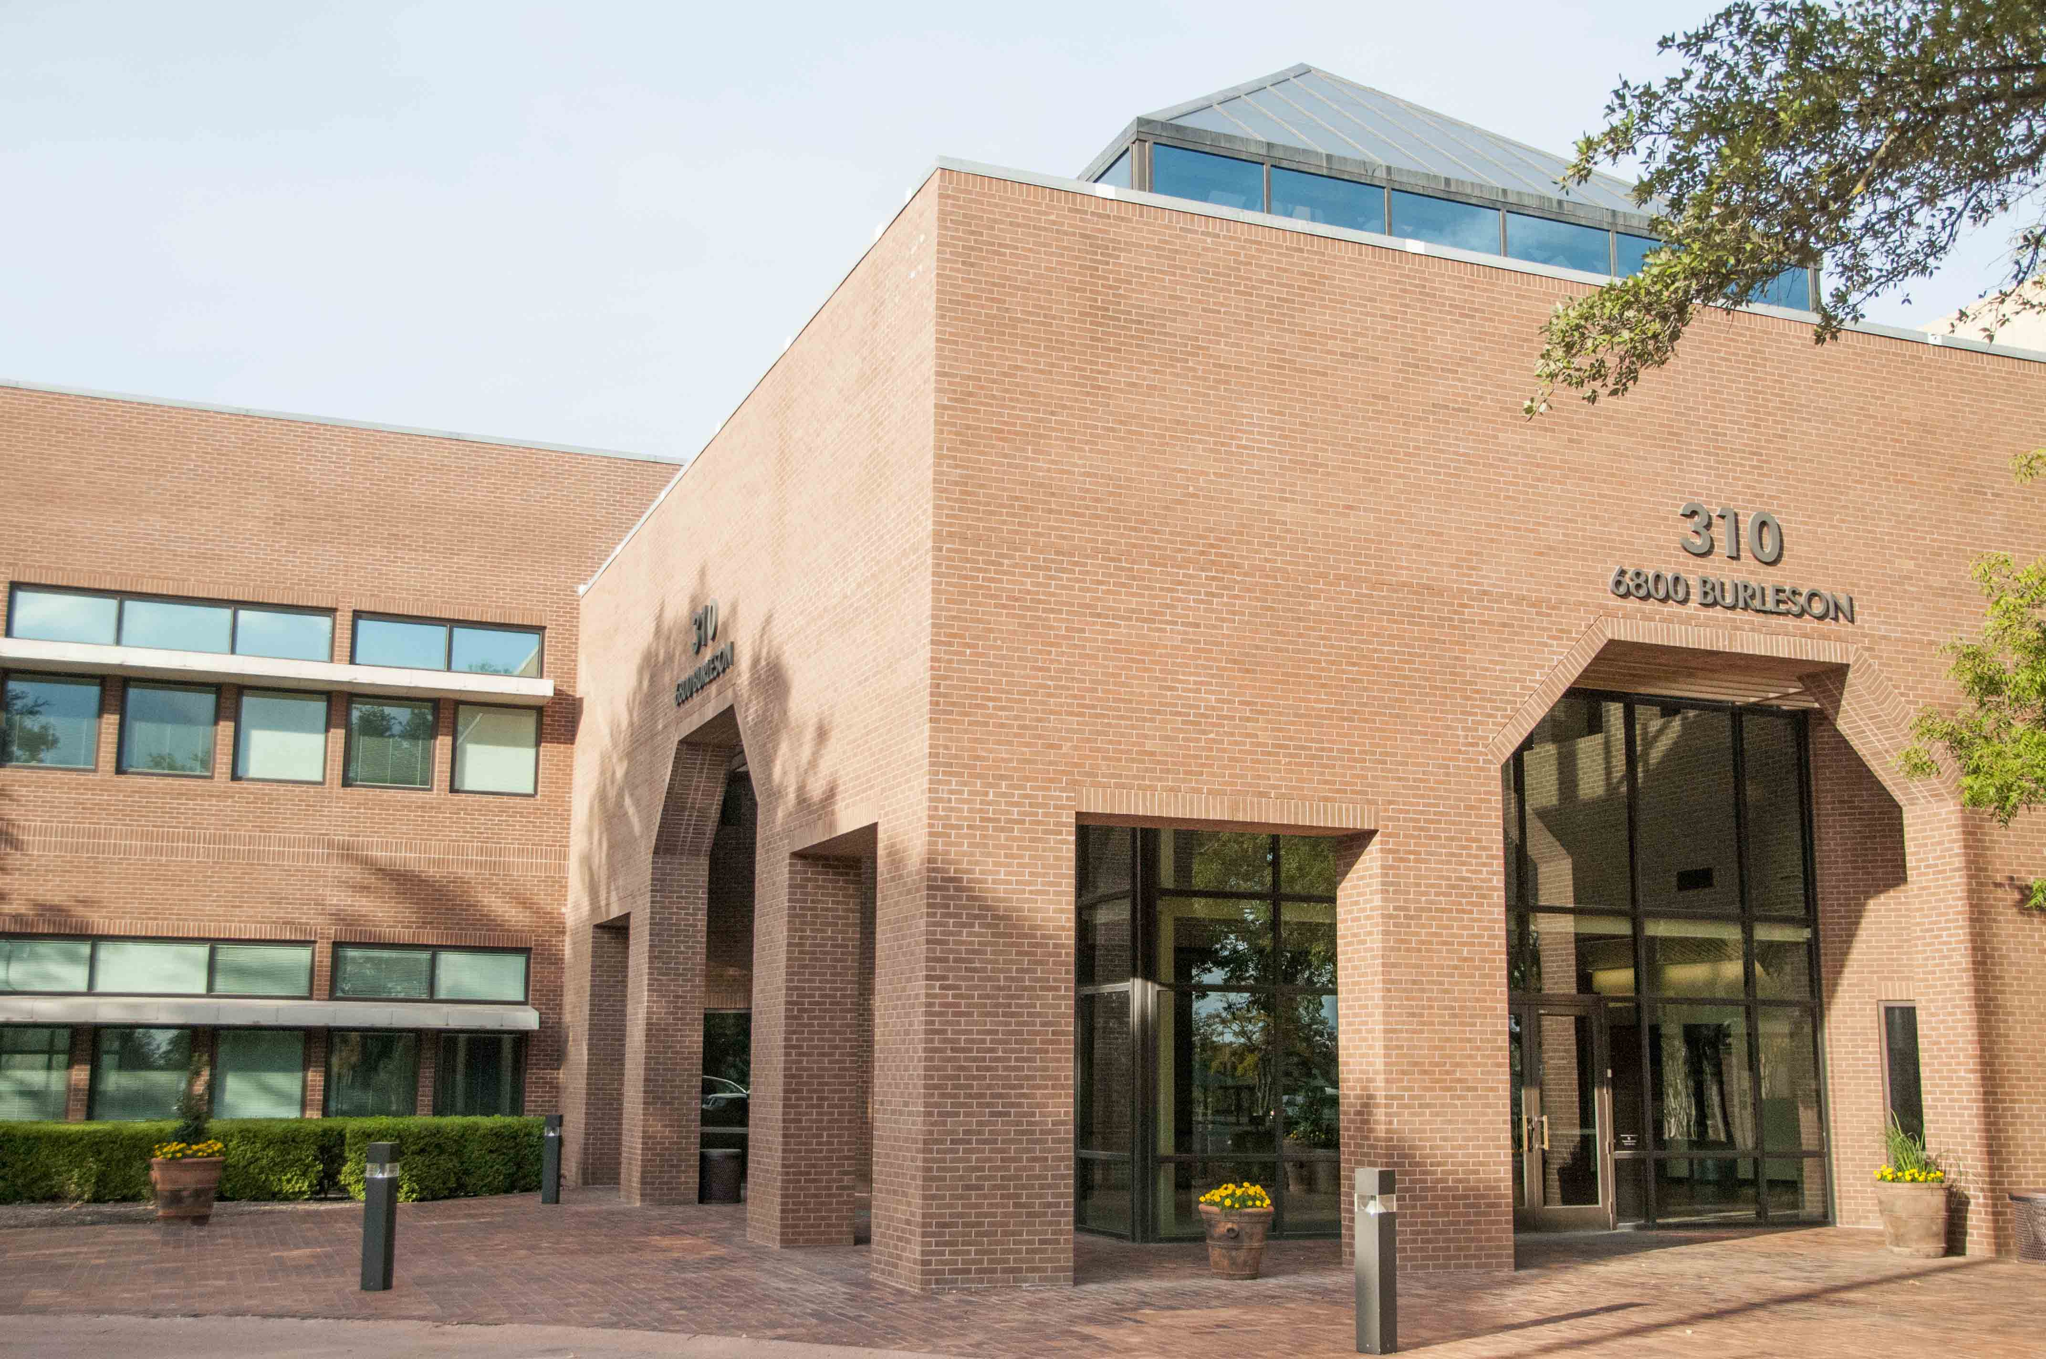

W. Gaines Bagby
First Vice President
T: +1 512 499 4915
gaines.bagby@cbre.com
Quick Facts
- CBRE researched and presented important detailed evidence that helped the Board choose the right place for its next site
- CBRE’s negotiations resulted in a significant savings to the cliente and a much more functional layout.
Challenge
CAPCOG was in multiple buildings into which it had grown over a period of years. The space layout was inefficient for CAPCOG’s use. Board members from a number of counties desired a building that would house Board meetings in an easily accessible location at a good value.
Solutions
CBRE studied a number of sites with easy access in South and Southeast Austin. A number of office and flex sites were identified that would yield a great space layout at a far better value than the existing space.
Results
CBRE helped CAPCOG work through several rounds of negotiations, and was nearing conclusion with one building, when one of the other buildings offered such an amazing economic deal that CAPCOG had to stop and seriously consider. It decided the new offer was just too good to turn down. The result was a savings of hundreds of thousands of dollars on the property new door. CBRE also handled the Project Management, guiding CAPCOG through architecture, engineering, construction, furniture, cabling and moving.

