Caritas :: Austin, Texas
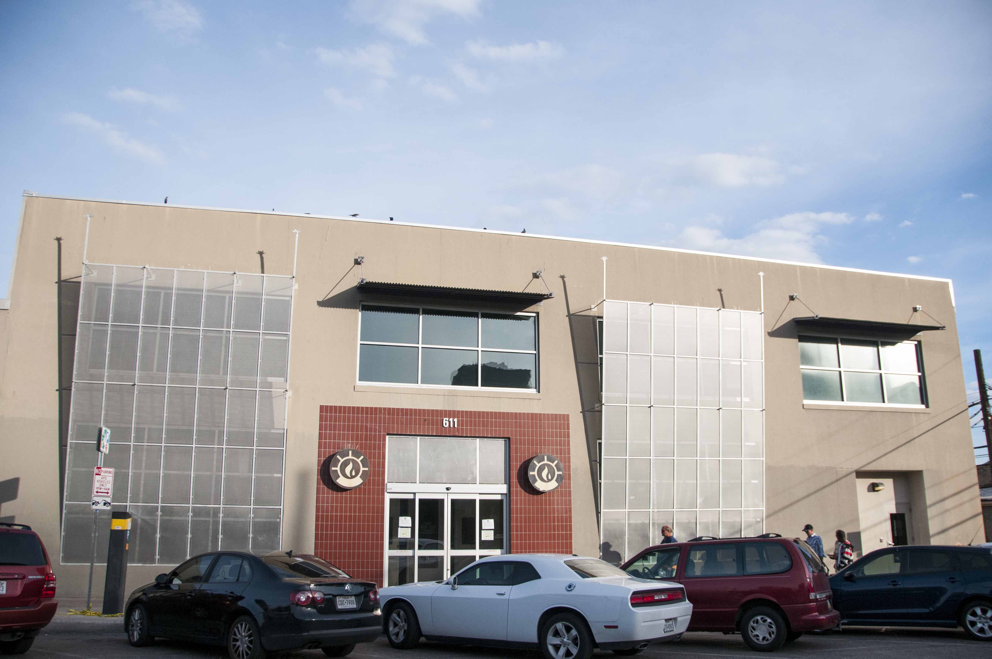

W. Gaines Bagby
First Vice President
T: +1 512 499 4915
gaines.bagby@cbre.com
Quick Facts
- Bagby was on the Board and was competent and well-known when the requirement surfaced
- Bagby knew the area well and was able to provide valuable insights to the Board that helped it know exactly what it wanted and select the right site quickly
Challenge
While celebrating its first fifty years servicing Austin, one of Caritas’ goals was to select the right site for its first satellite operation. It envisioned a retail site serving the Rundberg area in North Austin, but had not been in the market and did not know the best way to search the area and secure and finish out the site on a budget.
Solutions
W Gaines Bagby had served on the Caritas Advisory Board for years, and offered to manage the site search and selection process. A number of retail and quasi-retail sites in the area were considered and toured.
Results
CBRE was successful in directing the search and helping select a site that was not only far less expensive that most of the competition, but was uniquely located in a neighborhood surrounded by Caritas’ target population, and across the street from a bus stop. The site was dedicated in early 2015. Not long thereafter, the property owner decided to put the property on the market for sale. Bagby notified Caritas of the availability of the entire 17ksf property, as fully occupied, for sale. Through a special financing mechanism, Caritas was able to purchase the building, ensuring its long term growth in the area and allowing some of its stakeholders to invest in Caritas’ future.

