Television station :: Austin, Texas
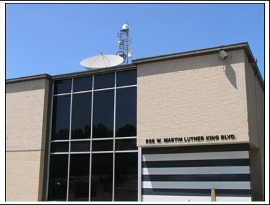

W. Gaines Bagby
First Vice President
T: +1 512 499 4915
gaines.bagby@cbre.com
Quick Facts
- Hired to identify a new site, with unique needs, for a news stations
- Developed and implemented a plan to expand station into a new facility at a lower cost than anticipated
Challenge
A major network television station hired CBRE after an initial site search and build-to-suit design was extraordinarily expensive.
Solutions
CBRE listened carefully to the client’s requirements and began a diligent search of the greater Austin area for an existing building that could be retrofitted for the station’s use. A tall transmission tower, dozens of satellite dishes, secure storage for expensive news vehicles, always-on power and huge fiber were all required. CBRE has been successful in identifying multiple sites that satisfy the client’s requirements at a very reasonable cost, and is working with the corporate decision-makers to assist them in determining which facility to place under contract and begin due diligence.
Results
CBRE developed and implemented a plan to expand the station into a new facility at a fraction of the cost it anticipated, while also showing it a way to significantly cut expenses on the disposition of its old facility.

